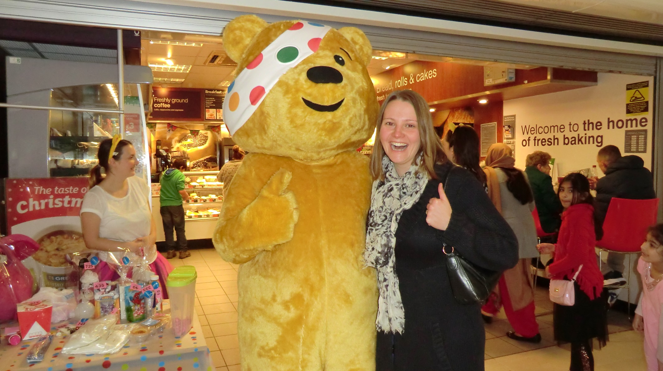

After Mulberry’s fantastic fundraising effort, Mrs Millar went to find Pudsey to share the good news. Pudsey was very pleased, and Mrs Millar was very proud!