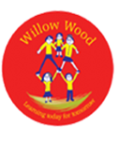

Learning Project WEEK 1 - My Family
Age Range: Year One
Weekly Maths Tasks (Aim to do 1 per day) | Weekly Reading Tasks (Aim to do 1 per day)
- Work on Primary Stars – you can join this for free access. Spring 2 work.  - Play on Hit the Button - number bonds,  - Practise counting in 2s, 5s and 10s. This game could support this.  - Practise telling the time. This could be done through this game (scroll down to access the game). Read to the hour and half hour.  - Write the numbers 0-20 in words and 0-100 in digits.  - Practise mental addition and subtraction by holding a number in your head and counting on or back. This game can help with this. https://www.topmarks.co.uk/learning-to-count/helicopter-rescue | - Reading a variety of books at home. Your child could share a book everyday. This can be reading a book aloud everyday or sharing a book with an adult.  - Listen to a story read, Storytime.  - Watch Newsround and find out what is happening in the world. What did you find out? Is there anything you need help understanding?  - Create a bookmark, perhaps you could choose characters from your favourite stories.  - Have a go at comparing two similar stories, what is the same and what is different.  - https://www.roythezebra.com/ to play a variety of reading games
Weekly Phonics/Spellings  Tasks (Aim to do 1 per day) | Weekly Writing Tasks (Aim to do 1 per day)
- Daily phonics - your child to practice their sounds and blend words. Interactive games found on link below.  - https://www.roythezebra.com/reading-games-singular-or-plural.html play this game to practise changing the ending of words to plural.  - Phonics play  - Top Marks  - Spelling  - Spell common exception words. Use Twinkl to help.  - Practice spelling days of the week. | - Draw a picture of your family. Underneath write a description of who is in your family – children to use adjectives (describing words) to describe each member of the family.  - Write a letter or postcard to a family member or a family friend who lives outside the home.  - Write a setting description on a place from your favourite story.  - Write a diary of what you did during the week.
Learning Project - to be done throughout the week: My Family 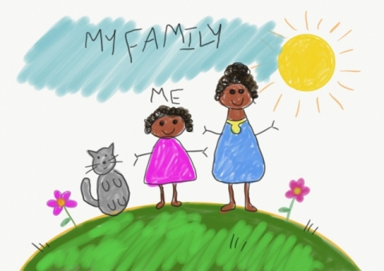
The project this week aims to provide opportunities for your child to gain a better understanding of their own family. Learning may focus on what different makeup of families, what traditions your family has, stories linked to your family etc.

Family:

- This is time to find out about their family and traditions they follow. Ask them to think about: Who they live with? How many adults? How many children? Can they sort their family members into height order? Who is the tallest? Who is the shortest? Is the tallest family member the eldest family member? If they drew around all their family members' hands; could they count in 5s? What if they drew around their feet? Could they count in 2s? Ask think about one family member they would love to interview. They could be a family member that lives with them or a family member that lives somewhere else. Can they write down some questions they would like to ask them? Have they got a pet? Can they draw or paint a picture of their family? Can they talk about their picture to a family member?

Self portrait:

- Ask your child to think about which materials they use to draw? Can they find different materials around the house to help? Ideas

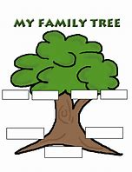
Family tree:

- Look at photographs of your family members and discuss where they would go on a family tree. Have you met everyone? Is there anyone you could interview and find out more about?

Design a personal coat of arms shield for the family:

- Find out what a coat of arm shield means. Ask them to begin to think about their design. What could they draw? What does it mean to them ? Ask them to think about the colours and shapes. Maybe if they have some cardboard around the house they could make a shield to give to a family member.

Create a booklet all about the family:

- Can they name the people in their family and write sentences about them? Who are they? What do they call them? What do they like or dislike? Why are they special to them? Maybe they could get a photograph or draw a family member before they write about them.

News Reporter for half a day:

-Their challenge is to interview family members and find things they like and dislike? Can they write down things they like and dislike? Can they compare these to someone else in their family? In your interview they could create flashcards with words such as: colour, clothes, food, drinks, books, places, music and then ask a family member to pick a flash card and talk about their likes and dislikes.

Data detective Ask your child to look at people in the house. What colour is their hair ? Eye colour? Favourite colour? Favourite food? Ask them to collect this and place in a tally chart.
https://www.twinkl.com.qa/resource/t2-m-250-favourite-colour-tally-and-bar-chart-worksheets

Write an invitation to a family event: Ask your child to invite a family member to one of the following: - (talent show, music show, magic tricks, jokest) In their invitation ask them to think about the time, date and place. How will they design the invitation? Who will deliver it?
Share the https://family.gonoodle.com/activities/milkshake movement and mindfulness video with their family. Who was the best? Which part did they enjoy? Could you create a video of your own?

Additional learning resources parents may wish to engage with
Classroom Secrets Learning Packs - These packs are split into different year groups and include activities linked to reading, writing, maths and practical ideas you can do around the home.
Twinkl - to access these resources click on the link and sign up using your own email address and creating your own password. Use the offer code UKTWINKLHELPS.
Headteacherchat - This is a blog that has links to various learning platforms. Lots of these are free to access.

Additional Year 1 phonics support can be found here:
https://home.oxfordowl.co.uk/reading/learn-to-read-phonics/

Additional year 2 work to support SATs can be found here: https://www.theschoolrun.com/key-stage-1-sats-learning-journey

#TheLearningProjects

