Reception Home Learning Suggestions Week Beginning 11th May 2020
 | Reading and stories | Phonics, reading and writing | Maths skills | Other
Monday | Watch The very hungry caterpillar on  https://www.youtube.com/watch?v=75NQK-Sm1YY | Tell your grown up your favourite part of the story and why?  Can you now complete the sentence?  I like the story because……  Or  I did not like the story because | Shape hunter!  The Hungry Caterpillar is full of a certain shape as he keeps munching through everything! Do you know why the leaves are like that?  Explore the pages and see where you can find them.  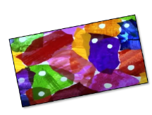  How many circles can you find on each page?  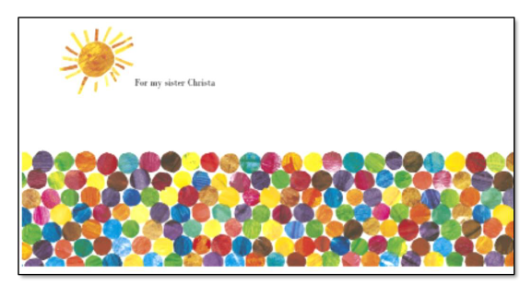  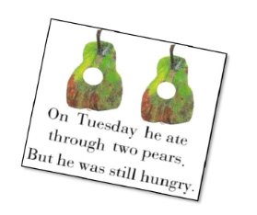 | The front pages of the Hungry Caterpillar are full of circles.  Could you make your own pages? How many circles would there be on yours? Does yours make a pattern? Think how you could make this more interesting.  Lots of other story books have hidden patterns in the front covers. Can you find any more in your stories at home?  What kind of pattern are they?  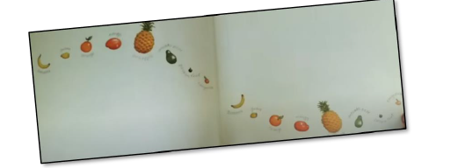  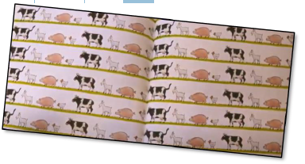
Tuesday | Watch The very hungry caterpillar on  https://www.youtube.com/watch?v=75NQK-Sm1YY | Can you write a shopping list of the different foods in the story? | Can you order the days of the week. How many days do we have in each week? | A famous artist called Kandinsky used circles to inspire him to paint this picture. What do you notice about the circles? Could you create your own art with circles. Or any other shape? 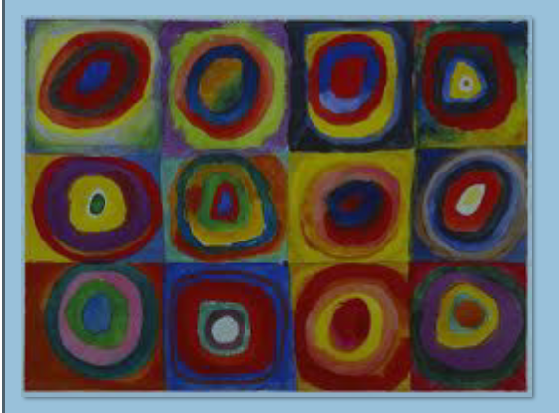
Wednesday | Listen to your child read for 10 mins. Oxford owl or a book from home  https://home.oxfordowl.co.uk/ | Look at the letters in the word ‘caterpillar’ and try rearranging some of the letters to spell other words e.g ‘pet’ and ‘rat’. Challenge the children to find other hidden words. | Can you draw/paint some little creatures with different amounts of body parts.  How many body parts would there be one less?  Can you make a caterpillar that is 3 less?  Paint or draw yourself some more caterpillars.  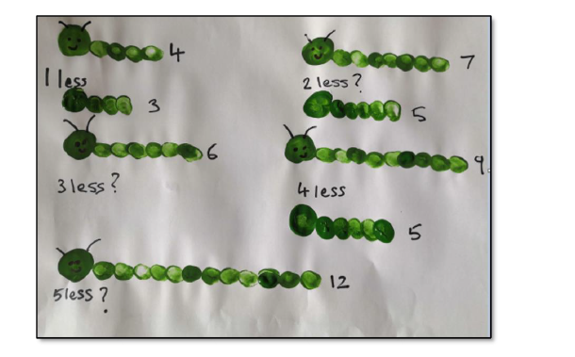 | Tomorrow you could have a picnic! For a proper picnic grown ups help us to get together what we will need. How many plates or napkins. What food shall we take? Do you need to make a plan or a shopping list.  Is there anything the Hungry Caterpillar ate that you haven't tried before?  For example. Have you tried a pickle?
Thursday | Listen to the ‘The crunching, munching caterpillar’  https://www.youtube.com/watch?v=upBBLJDYTWY | Write a diary.  On Thursday I……. | Enjoy getting your things out for your picnic how are you going to share your food? To halve things we need to share into 2 equal groups. Have a look here. Have these 2 children each got the same? Look closer.  If there are more people at the picnic, let’s say 3, how many sandwiches could they have each? How will you share things for your picnic?  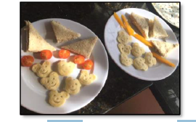 | Talk about how much of each thing you would have.  Could you draw your picnic on a paper plate  or a circle of paper? Could you find the food in magazines or make your own 3-D models?  Label your picnic and tell us how much of each food you would have. You can be as silly as you like!  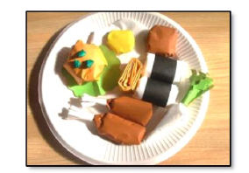
Friday | Listen to a CBeebies bedtime story | Make a list of the similarities/Differences between a caterpillar and a butterfly. | Have a look at the caterpillar. On quite a few of his body parts he has 2 little legs. Can you create some doubles with your caterpillars. You could draw on his legs!  Count how many body parts and double it to get the legs!  Think about some other double facts to tell your grown ups.  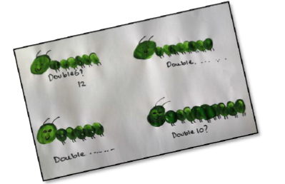 | Have a go at making your own butterfly.  Fold paper in half so you can see the line down the middle. Squeeze different colours of paint into the middle and fold over. Gently squidge the paint to the edges of the paper with flat hands. Open up and see your fantastic butterfly! Or use felt tips and ensure you draw the same pattern on each side –you could use a mirror to help you! If you don’t want to draw you can still look at matching patterns by using Lego!  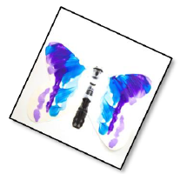  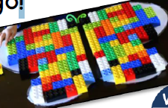

Please remember that these activities are suggestions only. Do not feel under pressure to complete all of these – you could pick and choose, repeat your favourites and definitely introduce your own! Whatever you get up to, please send us your photos, videos and messages via email. Naomi.coates@willowwood.cheshire.sch.uk.
Please keep yourselves happy and safe!

