Year 4 Summer Term 2 Learning Challenge, Week 3

Learning Project WEEK 3 UNDER THE SEA
Age Range: Year 4
Weekly Maths Tasks (Aim to do 1 per day) | Weekly Reading Tasks (Aim to do 1 per day)
- Ask your child to make a timetable of what you did or what you are going to do each day. Can your child write the times in 12hour and 24 hour clock?  - Ask your child to time how long it takes to do an event such as brush their teeth. Then ask them to multiply that number nu the times they do that task per day. How long is that in minutes? How many minutes is that over a week?  - Try drawing a clock on the ground with chalk. Then get them to use their body to make hands of the clock. They could just show the minute by lying straight or they could use their body to make both hands.  - Your child can create a large grid on the floor to represent a map of the ocean, with various hazards included. Then, ask your child to make a paper boat and use directional language (half turn, quarter turn, clockwise, anticlockwise) to navigate their ship safely across the ocean.  - REMEMBER to practise your times tables and column addition and subtraction.  - Don’t forget to keep up with your challenges on TT Rock Stars!  - Finally, draw another clockface with chalk, then split in into halves, then quarters, then eights and find equivalent fractions such as ¼ = 2/8 etc… | - Listen to your child read and encourage them to read with expression. Can they create a book review or write a summary of what they have read?  - Try researching and reading online together about an ocean creature of your choice. Here are some facts about turtles to get you started.  https://www.natgeokids.com/uk/discover/animals/sea-life/turtle-facts/  - Ask your child to listen and read along with two of the poems in the Under the Sea collection. Compare the different uses of language in each one.  https://childrens.poetryarchive.org/collections/under-the-sea/  - Can your child make an ‘Under the Sea’ themed book mark or reading area? They could include some of the new vocabulary they have learnt this week.  - Ask your child to read from Ocean Emporium. They can use a dictionary to clarify unfamiliar vocabulary. https://www.lovereading4kids.co.uk/extract/15536/Ocean-Emporium-by-Susie-Brooks.html  - Continue reading The Children of Lore on https://www.freechildrenstories.com/ In later weeks, we will create a ful book review.
Weekly Spelling Tasks (Aim to do 1 per day) | Weekly Writing Tasks (Aim to do 1 per day)
- Encourage your child to learn to spell the names of all the world’s oceans. Can they apply these into sentences?  - List each letter of the alphabet and ask your child to think of a sea related word that corresponds with each letter.  - Practise spelling these words: forgetting, forgotten, beginning, beginner, prefer, preferred, gardening, gardener, limiting, limited, limitation. Can your child identify the spelling rule/s?  - Ask your child to put these words in alphabetical order and then use a dictionary to find the meanings of each word:  marine, barnacle, crustacean, coral, mangrove & barracuda.  - Practise the Year 4 Summer non-negotiable spelling words. Can your child include some of these in their writing? | - Visit the Literacy Shed for this wonderful resource on the Lighthouse. Or ask your child to write their own under the sea rhyming poem.  https://www.literacyshedplus.com/resource/the-lighthouse-ks2-activity-pack  - Task your child with creating an information report about one of the world’s oceans. This could include a map locating the ocean, what plants and animals live there and the impact humans have on it.  - Ask your child to imagine they are a deep sea diver. Can they write a detailed description about the ocean and include specific species? Remind them to try and include adjectives to describe in detail what they saw.  - Encourage your child to write a ‘Finding Tale’ using ‘Finding Nemo’ as a stimulus. Who gets lost in the story? How do they find them?  - Ask your child to write an advert for a job to work on a submarine. How can they make the advert persuasive so lots of people apply?
Learning Project - to be done throughout the week
The project this week aims to provide opportunities for your child to learn more about life in and around the sea. Learning may focus on the strange and wonderful creatures and plants that occupy our oceans, their habitats and how human beings affect the environment.

- Let’s Wonder:
Can your child remember the oceans of the world? Encourage your child to find out about the five different layers of the ocean. (Sunlight Zone, Twilight Zone, Midnight Zone, Lower Midnight Zone or Abyss and the Trenches). Sea creatures adapt incredibly to live in specific layers where the conditions, such as temperature and light levels can change. Can your child explore the creatures that are found in each layer and create a fact file for each layer with a labelled diagram?

- Let’s Create:
Ask your child to look at pictures of real submarines for inspiration and create their own model using different materials found at home e.g. plastic bottles, paint, coloured pencils, string, paper mache, foil and cardboard. When you child is collecting materials, question them on the suitability of each material. Remember to tweet a picture of your models.
- Be Active:
Ask your child to try some Yoga using the Cosmic Kids Youtube channel. There are lots of ‘Under the Sea’ themed yoga workout and even a Mona-themed adventure!

- Time to Talk:
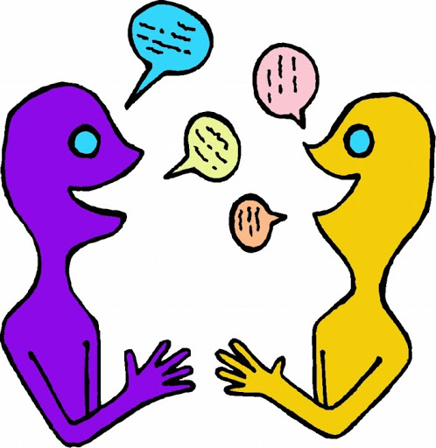
Encourage your child to ask different family members what they know about plastic waste (plastic bags, microbeads) that end up in the ocean. They could do this by creating a questionnaire and carrying out interviews. Discuss how you could help reduce ocean pollution and work together to create a persuasive poster to reduce plastic waste.
- Reef Research:
The Great Barrier Reef is the only living thing which is visible from space! Encourage your child to take a virtual tour of the reef using AirPano and create a poster or video to promote the Great Barrier Reef. Ask them to use scientific language relating to the habitats and species groups found in the reef. Can your child identify the main threats to The Great Barrier Reef and include these too?

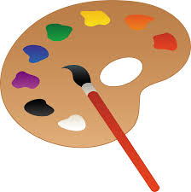

Additional learning resources parents may wish to engage with
Classroom Secrets Learning Packs - These packs are split into different year groups and include activities linked to reading, writing, maths and practical ideas you can do around the home.
Twinkl - to access these resources click on the link and sign up using your own email address and creating your own password. Use the offer code UKTWINKLHELPS.

#Teamwillowwood

