Reception Home Learning Suggestions Week Beginning 22nd June 2020
 | Reading and stories | Phonics, reading and writing | Maths skills | Other
Monday | Watch ‘What the ladybird heard’  https://www.youtube.com/watch?v=abKadke35cs  Listen to your child read for 10 mins. Oxford owl or a book from home  https://home.oxfordowl.co.uk/ | Watch Phonics session 15  https://www.youtube.com/watch?v=avg7f4o6Zb0  Super sentence – can you write a sentence about this picture? | https://wrm-13b48.kxcdn.com/wp-content/uploads/2020/homelearning/early-years/Day-1-What-the-ladybird-heard.pdf  Looking at the farm together. Talking about groups - from the first page.  Recall the animals on the farm with your child.  Paint or draw to make your own characters looking at how many legs, where they live and what sounds they make.  Use the book or this picture to discuss the animals in the story. Talk about who you are going to draw next e.g. this animal has feathers, this animal has 1 beak or this animal has 4 legs!  Can your child guess?  Get your child to test you - Play I am thinking of an animal! | Two coloured daisy experiment – see below
Tuesday | Go on teach your monster read website  https://www.teachyourmonstertoread.com | Watch Phonics session 16  https://www.youtube.com/watch?v=Gyjd2gqw_bU  Can you make a wanted poster for Lanky Len and Hefty Hugh?  See resources below. | https://wrm-13b48.kxcdn.com/wp-content/uploads/2020/homelearning/early-years/Day-2-What-the-ladybird-heard.pdf  Make Ladybird biscuits (see recipe below)  Simply decorate your biscuits with as many spots as you want and then talk about how many you have put on each side of the ladybird! How many spots altogether?  Set a challenge of each biscuit having to have 5 or 10 spots. How many on one side, how many on the other? Talk about the calculation on both sides of the biscuit to make 10. Another way! Each ladybird must have the same amount of spots on each side. How many different doubles have you got? What do these make? | Learn ‘What the Ladybird Heard’ song  https://www.youtube.com/watch?v=7NbyiDpY6Ww
Wednesday | Listen to your child read for 10 mins. Oxford owl or a book from home  https://home.oxfordowl.co.uk/ | Watch Phonics session 17  https://www.youtube.com/watch?v=4KnggnLIy00  listen to ‘What the Ladybird Heard’  Can you identify the rhyming words used throughout the book?  Can you think of your own rhyming words?  Cat, mat, fat  Can you put some into sentences?  The fat cat sat on the mat! | https://wrm-13b48.kxcdn.com/wp-content/uploads/2020/homelearning/early-years/Day-3-What-the-ladybird-heard.pdf  In the story the two baddies make a map of the farmyard in a cunning plan to steal the cow. (Even though it doesn’t go well!)  Have a go at making a map of the farm like the baddies using positional language! | Can you sort the animals in the story? Which ones have two legs? Which have four legs? Which ones have a beak or a nose? How many other ways could you sort them?
Thursday | Watch ‘What the Ladybird Heard Next’  https://www.youtube.com/watch?v=Cq0xiXoX8H0 | Watch Phonics session 18  https://www.youtube.com/watch?v=8DEZnGT9I-U  Look at the adjectives (describing words) that are used to describe each animal. How many other adjectives can you think of to describe them?  Fat, red hen | https://wrm-13b48.kxcdn.com/wp-content/uploads/2020/homelearning/early-years/Day-4-What-the-ladybird-heard.pdf  In the story “What the Ladybird Heard Next” the two baddies keep on stealing eggs from the hen.  Play Kim’s game by laying out different size coloured eggs on a tray or on a flat surface. Cover with a cloth. Grown ups take one away. Lift off cloth. Children tell us which one has gone. | Think about what stealing means and why it is wrong. How would you feel if someone stole from you? What happens to people who steal things from others?
Friday | Go on teach your monster read website  https://www.teachyourmonstertoread.com | Practise Phase 3 tricky words https://youtu.be/R087lYrRpgY  Super sentence | https://wrm-13b48.kxcdn.com/wp-content/uploads/2020/homelearning/early-years/Day-5-What-the-ladybird-heard.pdf  Draw out sets of dots on squares of paper or post it notes. Make these look like the patterns on a dice from a game. Lay these out on the floor in spaces. Hide up to 6 small items like dried beans or smarties (of the same colour) under a cup or a plant pot if you have one. You will then need something to swat with-a fly swatter or a plastic egg flipper or spoon!  Get your child to come near to the plant pot/cup and close their eyes. Grown ups hide 1-6 beans. Open your eyes. Lift off the plant pot. Children it’s your job to swat the correct number of spots as quickly as you can! Repeat with different amounts under the pot.  This game is more about instantly recognising numbers rather than counting – this is called subitising. If you would like to know more please look at our schemes for Reception. | How many different animals appear in the story? How are they similar / different?
Please remember that these activities are suggestions only. Do not feel under pressure to complete all of these – you could pick and choose, repeat your favourites and definitely introduce your own! Whatever you get up to, please send us your photos, videos and messages via email. Naomi.coates@willowwood.cheshire.sch.uk.
Please keep yourselves happy and safe!

Keeping fit is really important for our health but it also makes us feel great. We know how much you love our daily wake and shake in Reception so why don’t you try P.E with Joe Wicks live on YouTube to start off your day!

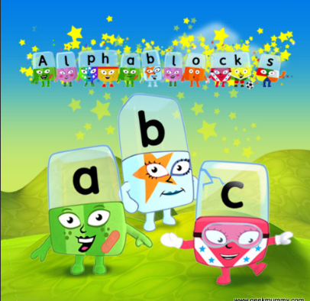
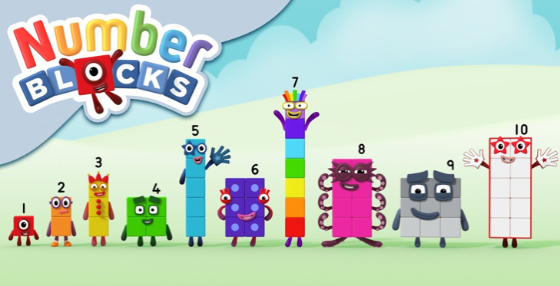
Remember these? Why not watch a few episodes to help with your numbers and phonics? Both programmes can be found on bbc iplayer.

Super Sentences
Can you write a sentence to go with these pictures? Remember to use your super phonics to help sound out those words.

Ladybird Biscuits
You will need:
1 pack plain biscuits
1 small, red food colouring Icing sugar
1 small cup of water
Black ready made icing in a tube or
block or something similar to make spots and lines like raisins and liquorish. Optional – edible eyes!

Reception
Talking Together
1. Lay out your biscuits on a flat surface.
2. Mix a little water into your icing sugar until it starts to make a really thick paste.
3. Add red food colouring until the icing goes ladybird red.
4. Ice your biscuits to look like red ladybird wings.
5. Roll block icing into a thin sausage and make into a strip down the middle of each biscuit. (Or draw a line with icing or add a strip of liquorish.)
6. Roll little balls of black icing ready or get your raisins ready!

WANTED

Two Coloured Daisy Science Experiment
Method
- To start with, pour about 12-15cm of water into each cup.
- Add your choice of food colouring to each cup (a di erent colour in each). Be generous with the colours.
- Using the knife, the adult can slice the stem of the daisy in half, lengthwise.
- Leave about 6cm of solid stem at the top of the ower, near the head.
- Place the daisy so that one half of the stem is in one cup of coloured water and the other half of the stem is in the other cup of water.
- Make sure the stem is well submerged in the water in both cups.
- Watch and wait. The ower petals will start to change colour within the hour, so it may be an activity you keep checking back on, rather than watching all the time.
- The longer the ower stays in the water, the more colourful the ower will be.
You will need:
Large white daisy
Food colouring (2 colours of your choosing)
2 or more cups
Chopping board
Sharp knife (for adult use) Water

