Reception Home Learning Suggestions Week Beginning 29th June 2020
 | Reading and stories | Phonics, reading and writing | Maths skills | Other
Monday | Watch ‘Princess Mirror Belle and the Dragon Pox, Written by Julia Donaldson & Lydia Monks  https://www.youtube.com/watch?v=LAFaJfcqqt4  Listen to your child read for 10 mins. Oxford owl or a book from home  https://home.oxfordowl.co.uk/ | Watch Phonics session 19  https://www.youtube.com/watch?v=9W4WiN3NeE4  Super sentence – can you write a sentence about this picture?  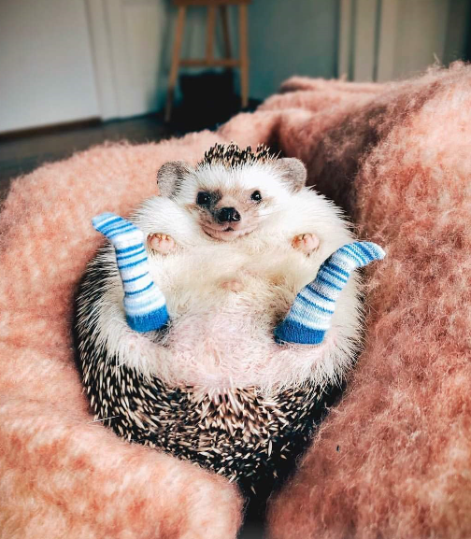 | 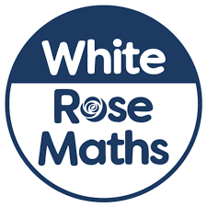  https://wrm-13b48.kxcdn.com/wp-content/uploads/2020/06/Day-1-Princess-Mirror-Belle.pdf  The princess has lots of spots! She has gone dotty, chicken pox spots but Mirror-Belle has made the patterns go wrong!  Tell us where the mistake is.  See resources below. | Princess Mirror-Belle boasts she lives in a very posh palace with maids and guards to hold her father’s beard! Design your own princess castle or palace and think about your use of 3-D shapes.  3-D Creations  Your palace may be made of things around your house to stick together – empty loo rolls/cereal boxes etc. Could you make a palace construction out of different 3-D objects around your house to make a structure?
Tuesday | Go on teach your monster read website  https://www.teachyourmonstertoread.com | Watch Phonics session 20  https://www.youtube.com/watch?v=9trjxKwC0xY  Can you complete the rhyming spells  Whirling and twirling,  And a tap of my hat.  Say this magic spell,  To turn into a…………..  (See resources below.) | https://wrm-13b48.kxcdn.com/wp-content/uploads/2020/06/Day-2-Princess-Mirror-Belle.pdf  Adding up those spots!  Princess Mirror-Belle and Ellen have a lot of spots! Can you find out how many pox spots they have?  Put them in the tens fames.  See resources below
Wednesday | Listen to your child read for 10 mins. Oxford owl or a book from home  https://home.oxfordowl.co.uk/ | Watch Phonics session 21  https://www.youtube.com/watch?v=JUBnHk_BRlg  Write the list of ingredients that you have used for your ‘dragon pox’ in todays maths activity  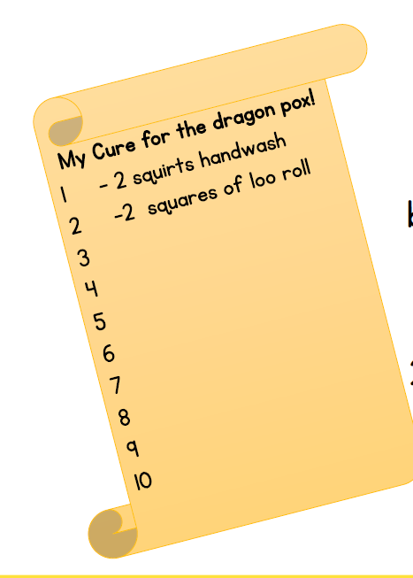 | https://wrm-13b48.kxcdn.com/wp-content/uploads/2020/06/Day-3-Princess-Mirror-Belle.pdf  How would you cure the dragon pox?  The Princess uses lots of strange things for a cure! What other things in your bathroom could you use to make a cure for the dragon Pox? | Bubbling potion Science experiment The Science Behind the Experiment – A Guide for Adults  Bicarbonate of soda is a chemical called sodium bicarbonate and is an alkali. Vinegar contains acetic acid. Mixing bicarbonate of soda and vinegar creates a reaction forming carbon dioxide which makes the bubbles and a residue of a  type of salty water.  What happens when the ingredients are mixed together?  What can you see?  What words can you use to describe your potion?  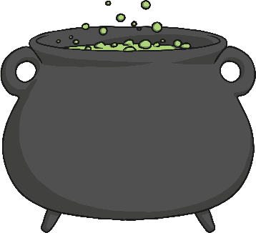  What colours can you see?
Thursday | Watch ‘Hector and the big bad knight.  https://www.youtube.com/watch?v=v4-QeRqyjno | Watch Phonics session 22  https://www.youtube.com/watch?v=waeQE-tK7ZA | https://wrm-13b48.kxcdn.com/wp-content/uploads/2020/06/Day-4-Princess-Mirror-Belle.pdf  Make number tracks with princess Mirror-Belle’s last cure for the dragon pox!  You will need.........  Toilet roll  Pens  Knowledge of your numbers! Choose to do a number track to 10 or to 20.  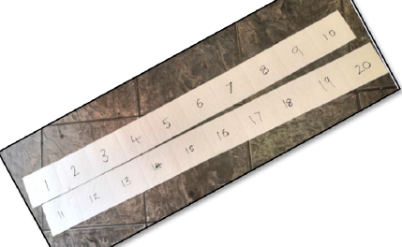  Once you have your number track use it to go and see what else around your house is 10 or 20 sheets long.  Are you 20 sheets tall?  Take this further.  Rip your sheets into ones and muddle them up! Can you put them in the correct order? Make a specific mistake and see if your grown ups can tell you where it is? | Our face in the mirror!  We thought you might like to draw your own face in the mirror to show us how much you’ve enjoyed yourself!  Keep smiling!
Friday | Go on teach your monster read website  https://www.teachyourmonstertoread.com | Practise Phase 3 tricky words https://youtu.be/R087lYrRpgY  Super sentence  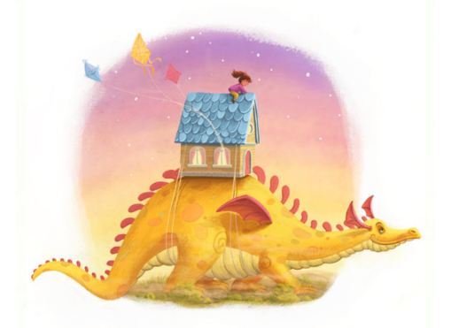 | https://wrm-13b48.kxcdn.com/wp-content/uploads/2020/06/Day-5-Princess-Mirror-Belle.pdf  Double my shoe!  The girls only had one slipper each!  Have a look in your wardrobe or wherever you keep your shoes? How many doubles – pairs can you find?  Explore the shoes in your house. They all should be in pairs! Who has the biggest feet?  Who has the longest feet?  Is this the same?  Can you put your pairs of shoes in order of size?  Can you make your own shoe shop? How much would different shoes cost? | Talking Together  You might not want to use the bath like Mirror-Belle.  You could try the sink and experiment how many of each different containers it takes to fill it.  Which do you think will be the quickest? Why? Will you need more pours of that container if it is bigger or smaller?  Happy splashing! Just don’t do what Mirror-Belle did!
Please remember that these activities are suggestions only. Do not feel under pressure to complete all of these – you could pick and choose, repeat your favourites and definitely introduce your own! Whatever you get up to, please send us your photos, videos and messages via email. Naomi.coates@willowwood.cheshire.sch.uk.
Please keep yourselves happy and safe!

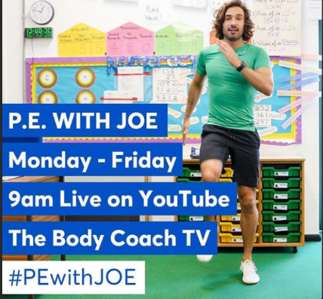
Keeping fit is really important for our health but it also makes us feel great. We know how much you love our daily wake and shake in Reception so why don’t you try P.E with Joe Wicks live on YouTube to start off your day!

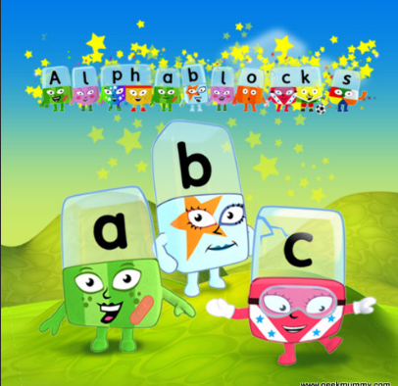
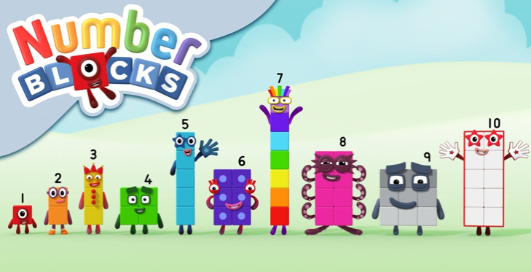
Remember these? Why not watch a few episodes to help with your numbers and phonics? Both programmes can be found on bbc iplayer.

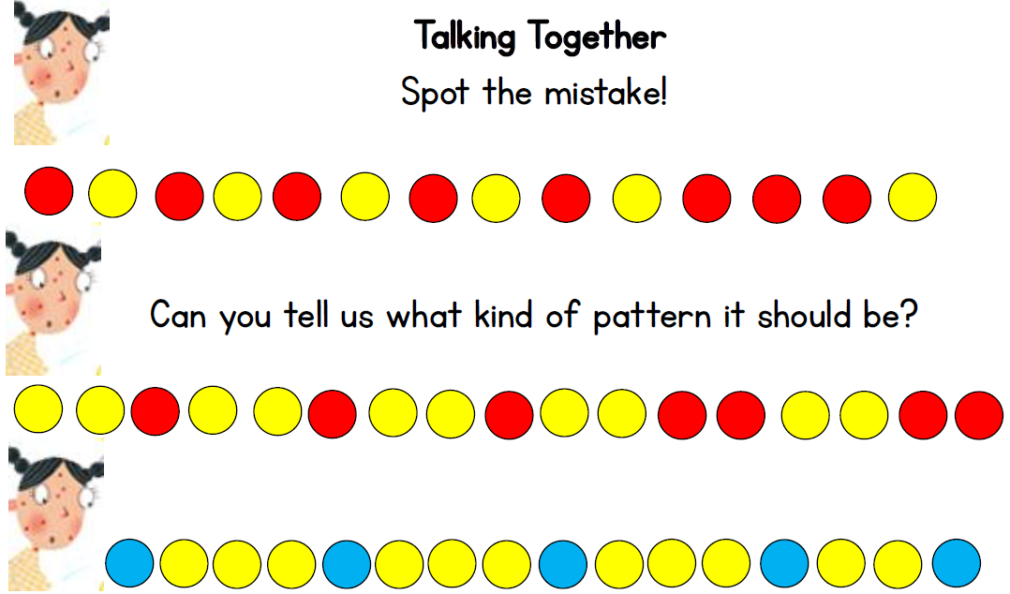
Monday maths

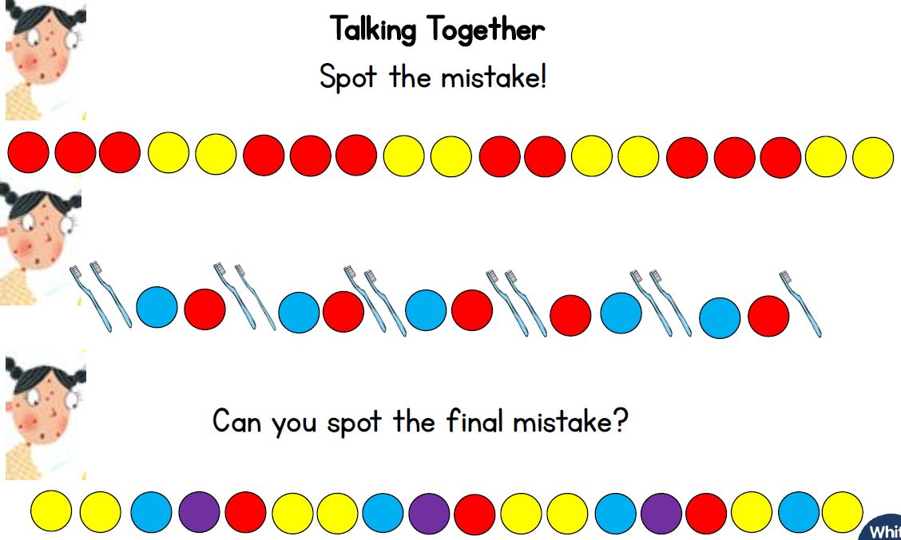

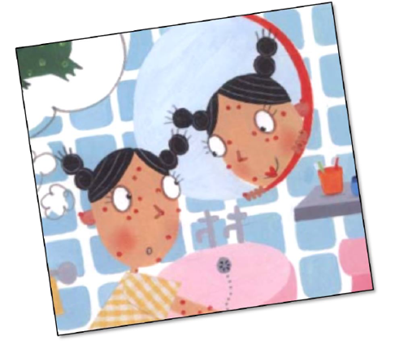
Tuesday maths
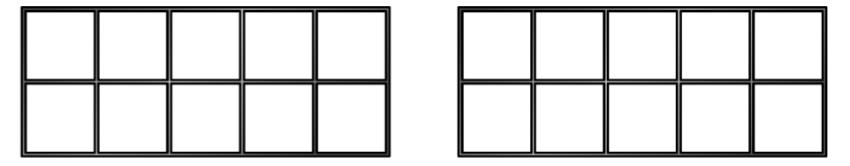

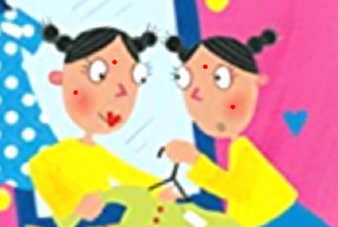

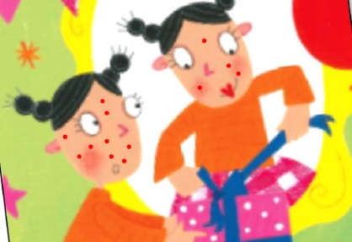

Super Sentences
Can you write a sentence to go with these pictures? Remember to use your super phonics to help sound out those words.
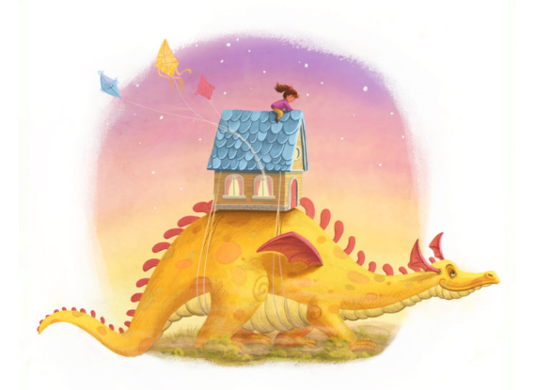
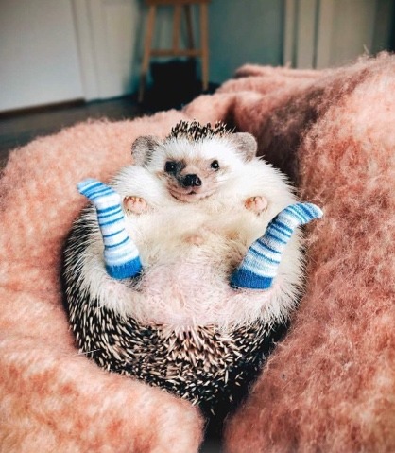

Tuesdays rhyming spells
Whirling and twirling,
Whirling and twirling,
A big puff of fog.
Say this magic spell,
To turn into a.......................

Whirling and twirling,
Like you’re mixing a cake.
Say this magic spell,
To turn into a.......................

Put your wand in a box.
Say this magic spell,
To turn into a.....................

Whirling and twirling,
And a tap of my hat.
Say this magic spell,
To turn into a........................

