Reception Home Learning Suggestions Week Beginning 13th July 2020
 | Reading and stories | Phonics, reading and writing | Maths skills | Other
Monday | Watch ‘Oliver’s Vegetables’  https://www.youtube.com/watch?v=2yvllKqyVUc  Read with your child  https://home.oxfordowl.co.uk/ | Watch Phonics session 27  https://www.youtube.com/watch?v=QDTMUEoXEwQ  Super sentence – can you write a sentence about this picture?  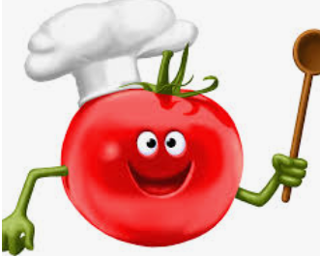 | https://wrm-13b48.kxcdn.com/wp-content/uploads/2020/06/Day-1-Olivers-Vegetables.pdf  Oliver only eats chips until he spends time with his grandad trying new things. That’s not very healthy. Can you do some healthy sorting?  Your task is to sort the different foods into healthy and not healthy. We are talking about food and drink that you shouldn’t have ALL the time, foods you might have as a treat. Have a look at vegetable glue to see what happens when you don’t eat your healthy vegetables!  See resources below | 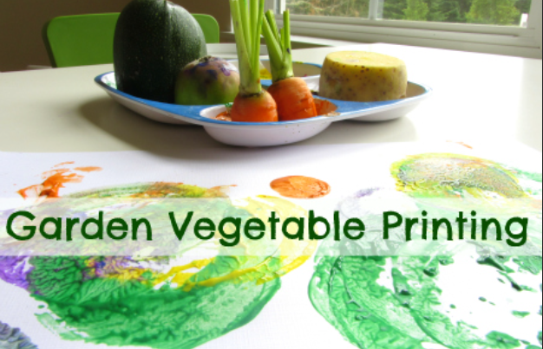  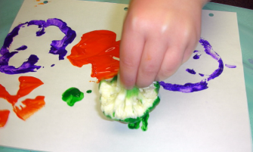
Tuesday | Go on teach your monster read website  https://www.teachyourmonstertoread.com | Watch Phonics session 28  https://www.youtube.com/watch?v=gxACCZOxbyM  Can you write a shopping list for when you next go shopping? | https://wrm-13b48.kxcdn.com/wp-content/uploads/2020/06/Day-2-Olivers-Vegetables.pdf  We have all been on a visit to the shops. Just like Oliver does in “Oliver’s fruit Salad“ and in “The Shopping Basket”. Play your memory game with someone in your house or a group if you are lucky! How many items can you remember? How silly can you make them?  In the series with Oliver there are many images of things to count and group. Look at the images and see how many ways you can see the numbers.  See resources below | We have all been on a visit to the shops. Just like Oliver does in “Oliver’s fruit Salad“ and in “The Shopping Basket”. Play your memory game with someone in your house or a group if you are lucky! How many items can you remember? How silly can you make them?
Wednesday | Listen to your child read for 10 mins. Oxford owl or a book from home  https://home.oxfordowl.co.uk/ | Watch Phonics session 29  https://www.youtube.com/watch?v=jMwtf5CRwZ0 | https://wrm-13b48.kxcdn.com/wp-content/uploads/2020/06/Day-3-Olivers-Vegetables.pdf  Oliver has been very busy helping his Grandad to plant vegetables. However……. he has forgotten how many he has planted! Help Oliver tell his Grandad how many more he has dug into the veggie patch!  See resources below | Time for a vegetable investigation. Use your chosen veg to measure the items in your house!  Job one, pick your vegetable (Carrots are good).  2. Pencil and paper ready. 3. Get measuring  4. Note down how many units (Carrots) high and long the items are. Suggestions Your bed Your table Your door Your bookcase Your television Have fun noting down and let us know what you have used!
Thursday | Watch ‘Oliver’s Fruit Salad’  https://www.youtube.com/watch?v=jcTprkImlmI | Watch Phonics session 30  https://www.youtube.com/watch?v=u9DY5Hfjkck  Can you write a set of instructions how to make a fruit salad?  - First wash the fruit  - Next peel and slice 1 banana  - Cut each grape in half | https://wrm-13b48.kxcdn.com/wp-content/uploads/2020/06/Day-4-Olivers-Vegetables.pdf  Oliver helps his grandad by sorting out the vegetables. They have had a bumper crop of fruit and veg this year but Oliver has got a bit confused counting them all! Can you help him out?  See resources below | Make a fruit salad for you family.  Ask you family what are their favourite fruits?
Friday | Go on teach your monster read website  https://www.teachyourmonstertoread.com  Watch ‘Oliver’s milkshake’  https://www.youtube.com/watch?v=AmREiMAGwkU | Practise Phase 3 tricky words https://youtu.be/R087lYrRpgY  Super sentence  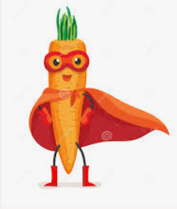 | https://wrm-13b48.kxcdn.com/wp-content/uploads/2020/06/Day-5-Olivers-Vegetables.pdf  Oliver was going to make himself a milkshake but now his friend has come too! Can you double the amount of ingredients so they both can have one?  See resources below | Make your own milkshakes just like Oliver. Pick your favourite fruit or fruits to make a frothy fantastic drink! You will need a grown up to help with the blender. Remember to count out your ingredients!
Please remember that these activities are suggestions only. Do not feel under pressure to complete all of these – you could pick and choose, repeat your favourites and definitely introduce your own! Whatever you get up to, please send us your photos, videos and messages via email. Naomi.coates@willowwood.cheshire.sch.uk.
Please keep yourselves happy and safe!

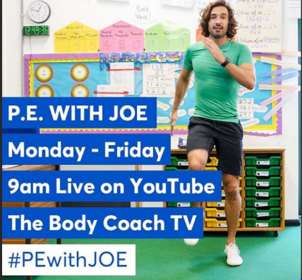
Keeping fit is really important for our health but it also makes us feel great. We know how much you love our daily wake and shake in Reception so why don’t you try P.E with Joe Wicks live on YouTube to start off your day!

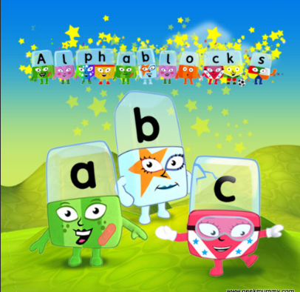
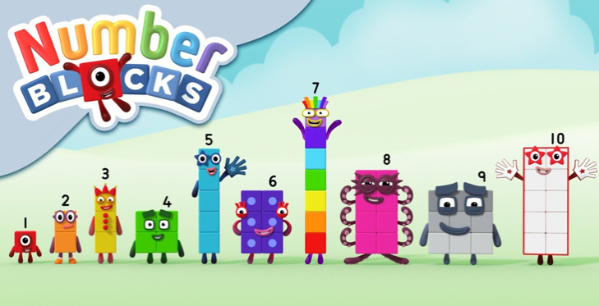
Remember these? Why not watch a few episodes to help with your numbers and phonics? Both programmes can be found on bbc iplayer.

Monday maths
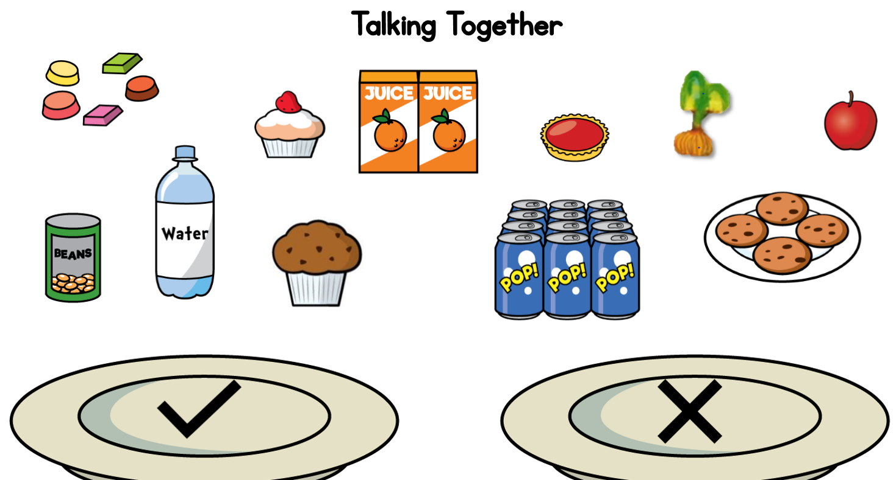
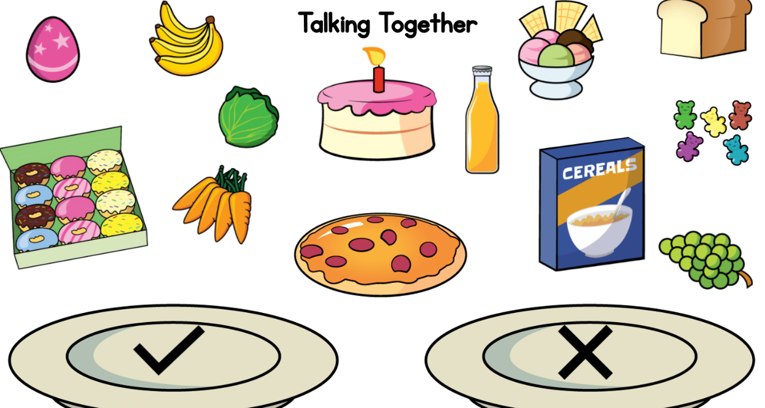

Tuesday
Shopping game
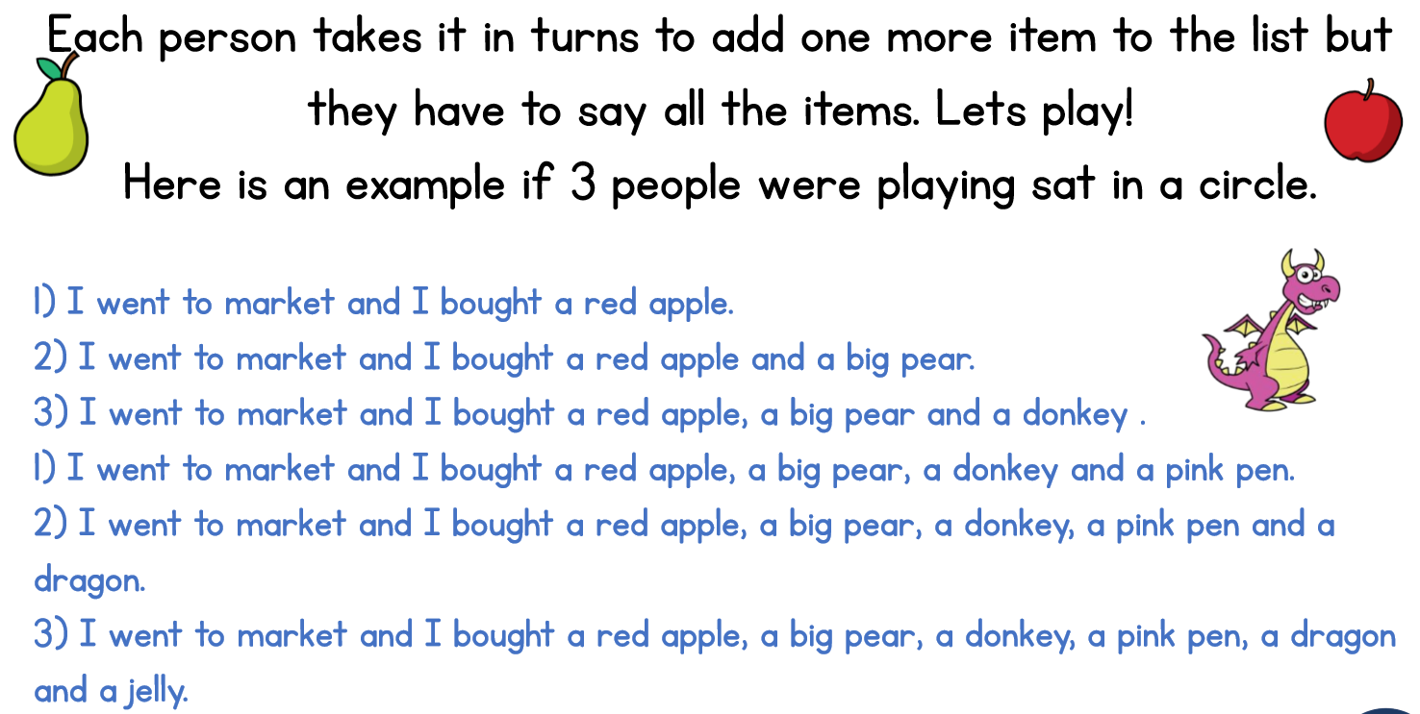
Maths activity
How many onions? Can you see them in groups of 2? How many flowers? Can you see them in groups of 2? How many carrots? How many strawberry bushes? Did you need to count them? How else do you see the things growing in the picture?
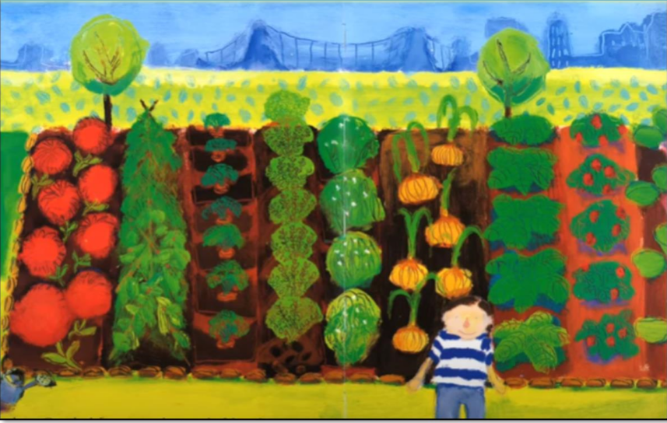

Wednesday maths

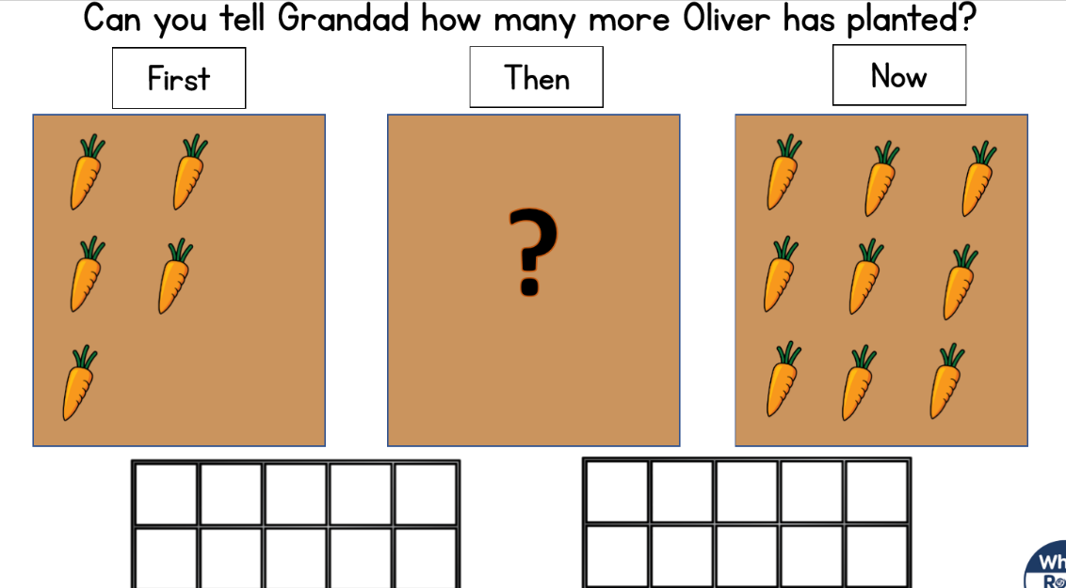
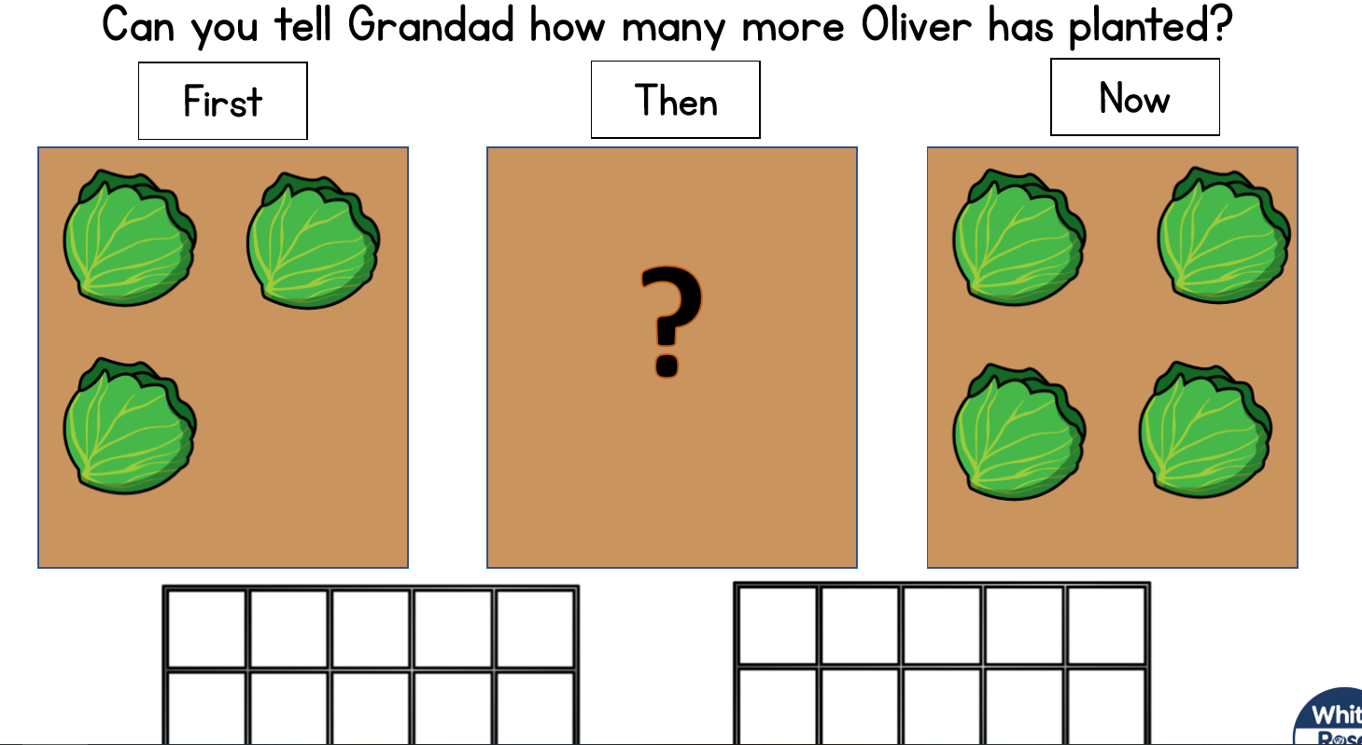
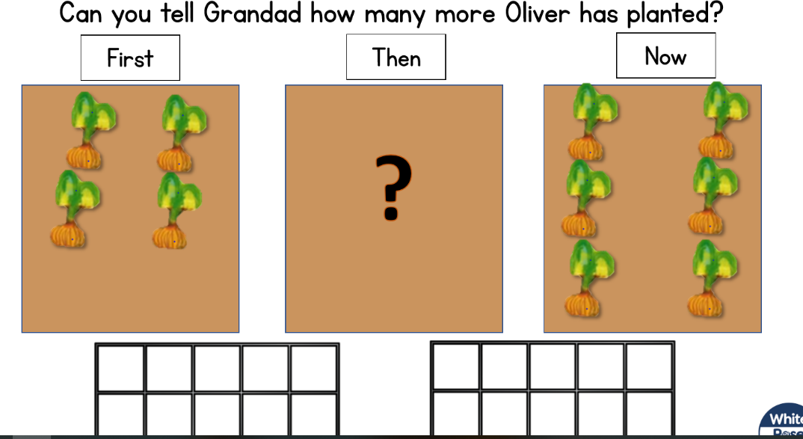

Thursday maths
Oliver has put a label on the crops from the garden, see if his labels are correct. Could you make him a correct label?
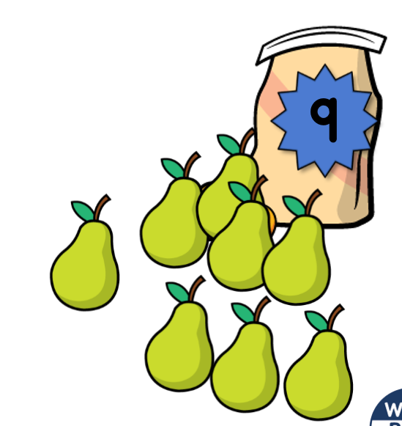
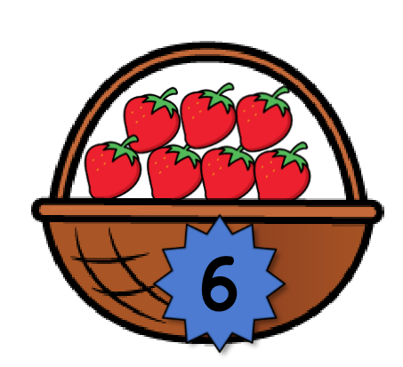
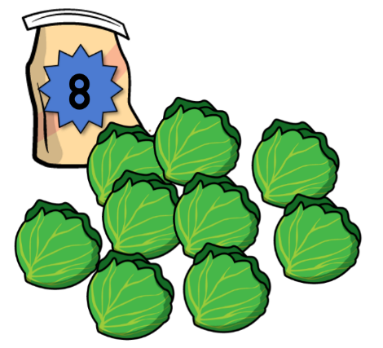
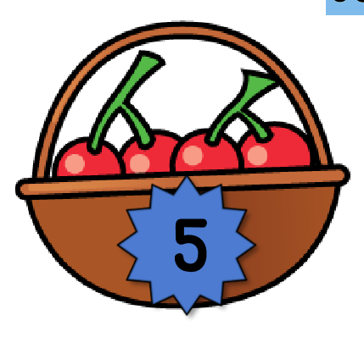

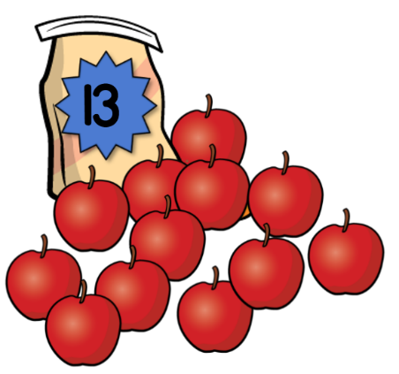
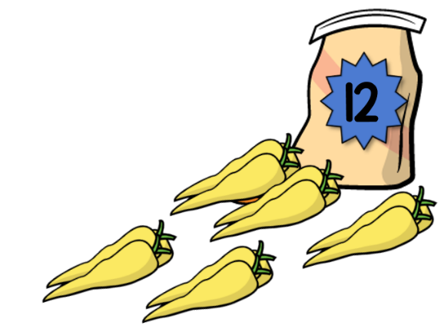

Friday maths
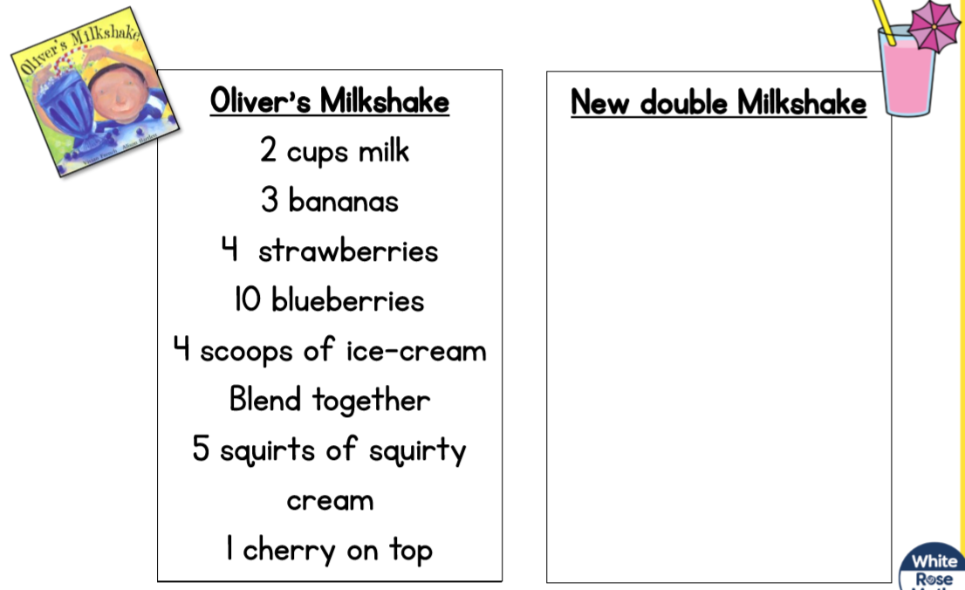
Tricky Problem What would the recipe say if another 2 friends came?

Super Sentences
Can you write a sentence to go with these pictures? Remember to use your super phonics to help sound out those words.

